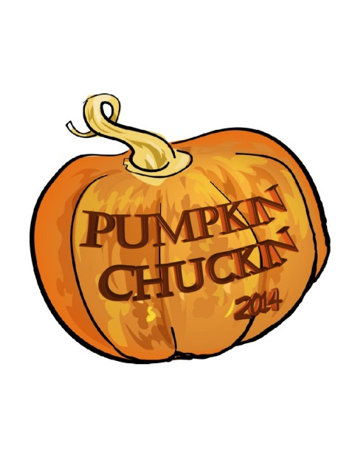

The Greater Union Grove Area Chamber of Commerce presents:
The Great Pumpkin Fest
Now Featuring

Pumpkin Chunckin

Saturday October 25th
10am – 4pm
Racine County Fairgrounds

A new and exciting competition called Pumpkin Chuckin will take place during The Great Pumpkin Fest, sponsored by the Greater Union Grove Area Chamber of Commerce on Saturday, October 25, at the Racine County Fairgrounds. A captain and three other team members will build a machine to launch an 8 – 10 pound pumpkin. There will be three Chucker Divisions – one for each type of machine: Trebuchet, Catapult, and Sling Shot.

Register your team today at www.uniongrovechamber.org !

All the elements that have made The Great Pumpkin Fest a popular fall family event are still there, including prizes for best costumes, pumpkin baking competition, chili cook-off, pie eating contest. This year the Fest will also include a pie acution, food and craft vendors, hay rides and much more! Mark Saturday, October 25, on your calendar!

